AWS Static Site Lab

Creating a STATIC PUBLIC WEBSITE

Marcello Novak | CCNP

***Purpose***

This lab dealt with the creation of an Amazon S3 bucket to host a static website. This requires enabling said bucket for webhosting, setting permissions, adding policy, and verification.

***Screenshots***



The bucket itself, showing public access.

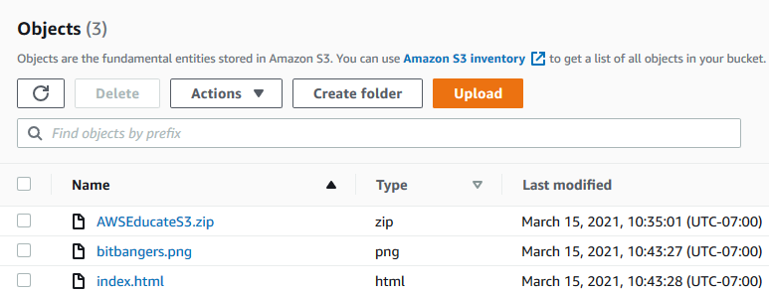

The website files hosted within the bucket itself.

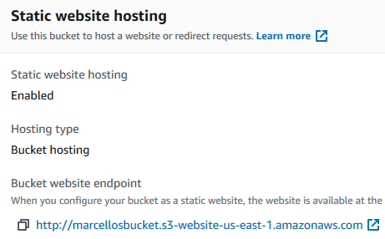

The properties, showing enabled website hosting.

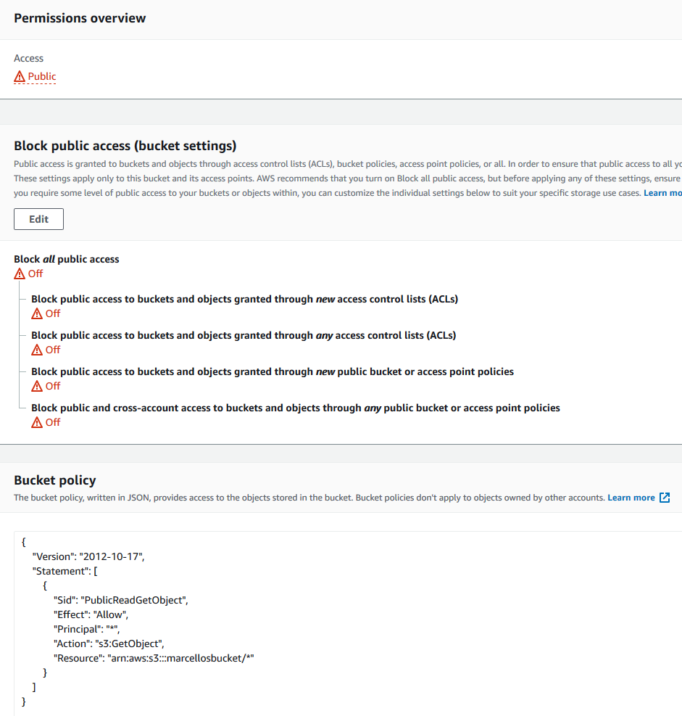

All of the policies allowing for public access.



The header for the actual website, once hosted.

***Problems***

Like my first AWS lab, this went smoothly as well. I really didn’t find any difficulty with this lab, but I could see how this could be difficult without a guide. Overall, I found this lab fun and educational, as cheesy as that sounds.